Setting-Up Your Reagan-Fascell Democracy Fellowship Application Account

Step 1.
- Visit our online application portal: https://www.nedfellowships.org/

Step 2.
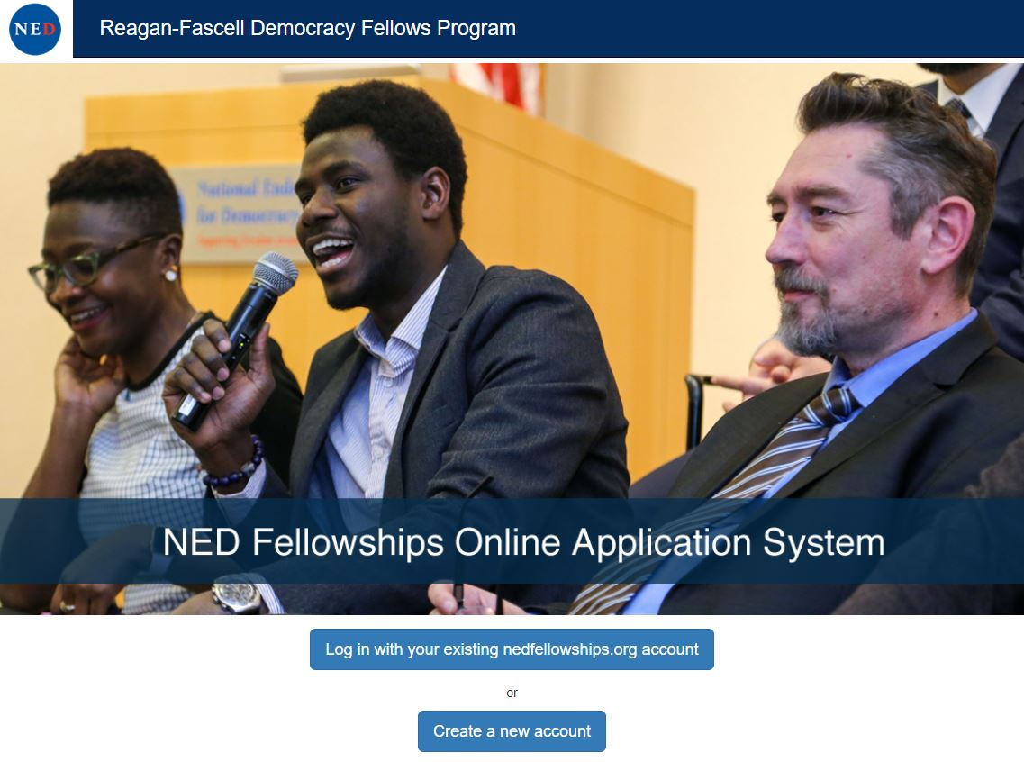
- Click on “Create a new account.”

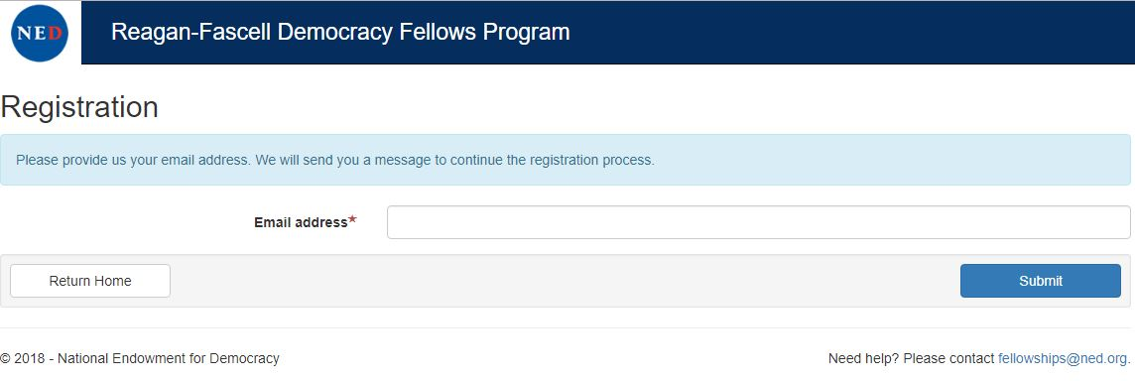
- Enter your email address on the Registration page.

Step 3.
- A confirmation link will be sent to the email you provided from noreply@nedfellowships.org. Please check your spam folder if you do not see an email.
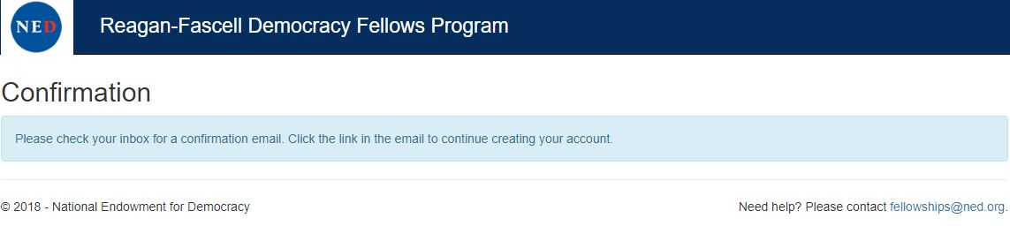

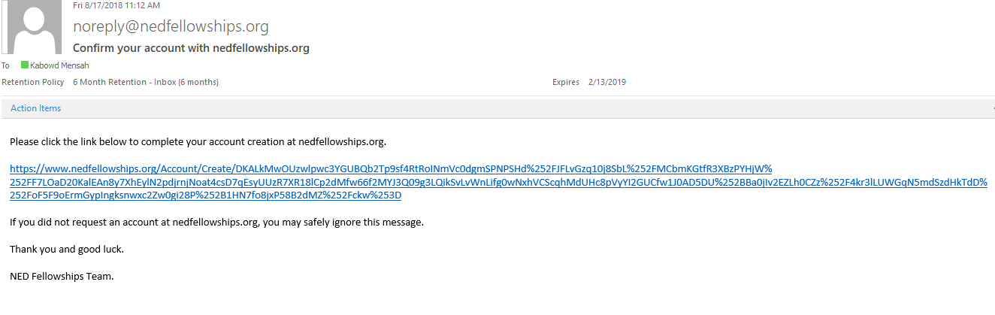
- Click the link provided in the confirmation email.

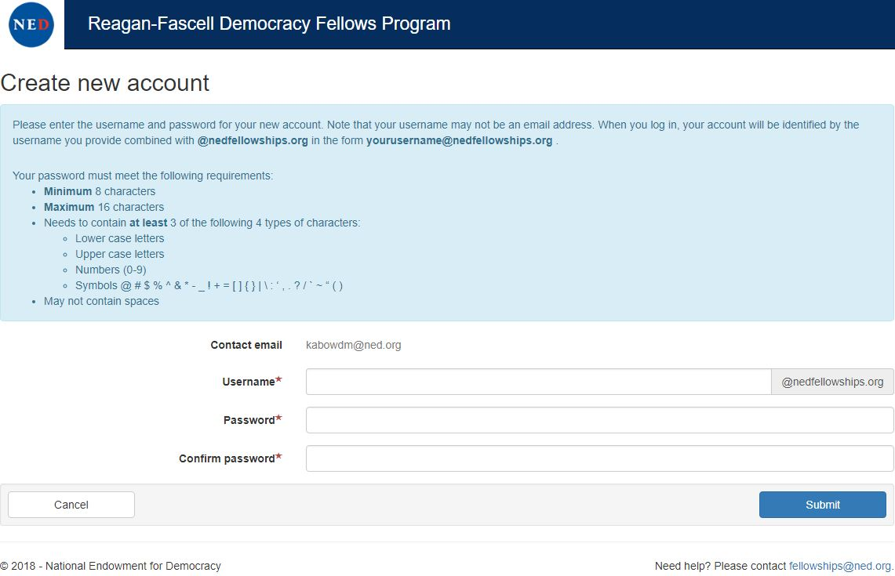
- You’ll be brought to a webpage where you will create a username and password.

- Click ‘Continue to Login’ when you create a new account successfully.
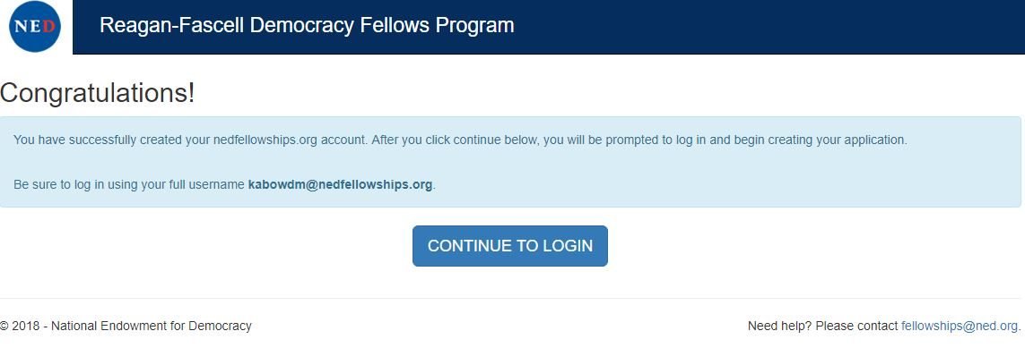

- To sign in, enter your created username ending with @nedfellowships.org. Do not enter your personal email address. Insert your created password when prompted afterwards.
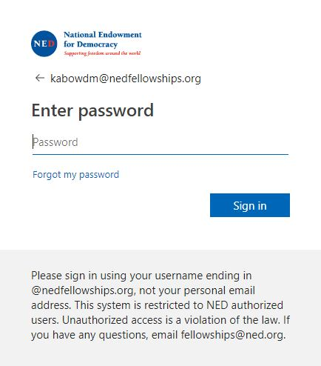
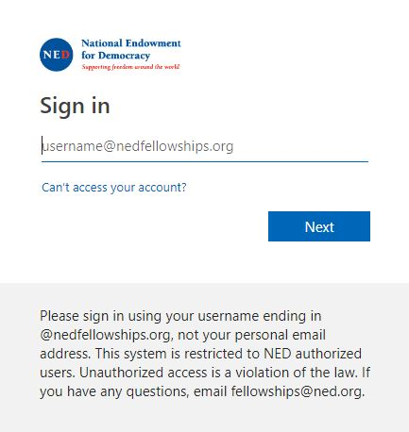

Step 4.
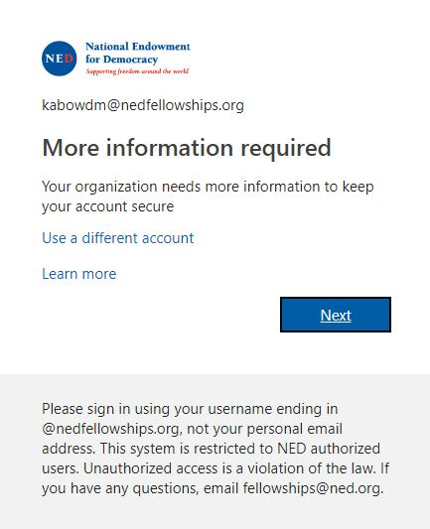
- More information will be required when you log in for the first time. When prompted, click the ‘Next’ button.

- You’ll be asked to authenticate either your phone number, your email address or answer some security questions. If you forget your password to the account, you’ll be able to regain access. Remember that you’ll only have 15 minutes to complete each task in this step, or you’ll be automatically signed out.
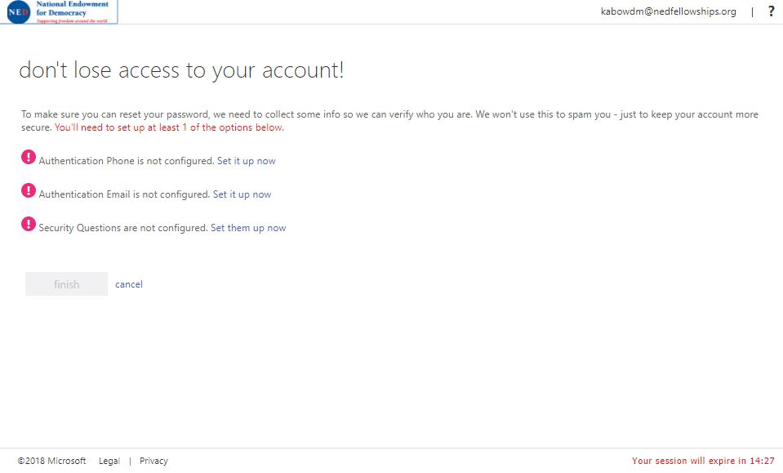

- If you choose to authenticate your email address, you’ll be prompted to enter it once more. Remember that you can use the same email used in Step 2, part b.

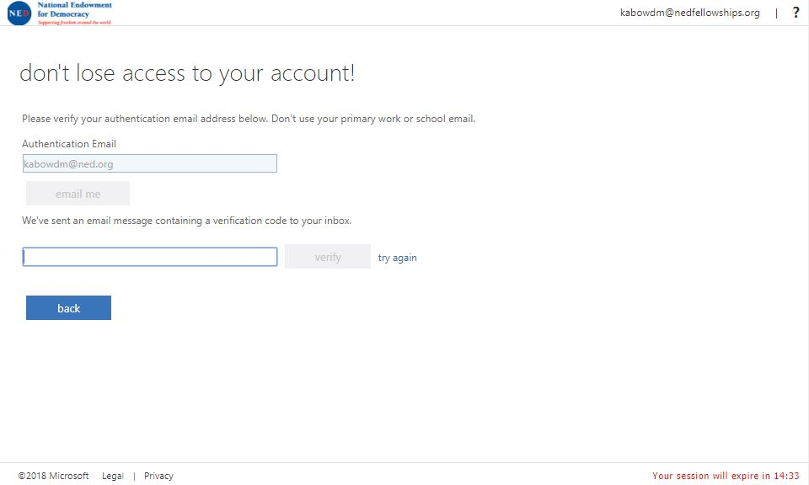

- You’ll receive a 6 figure code in your email. Don’t forget to check your spam if you do not receive an email.
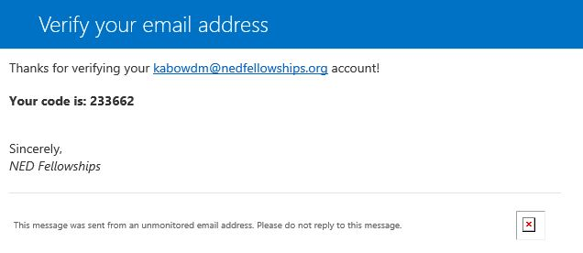

- Enter the code in the designated box and click ‘Verify.’
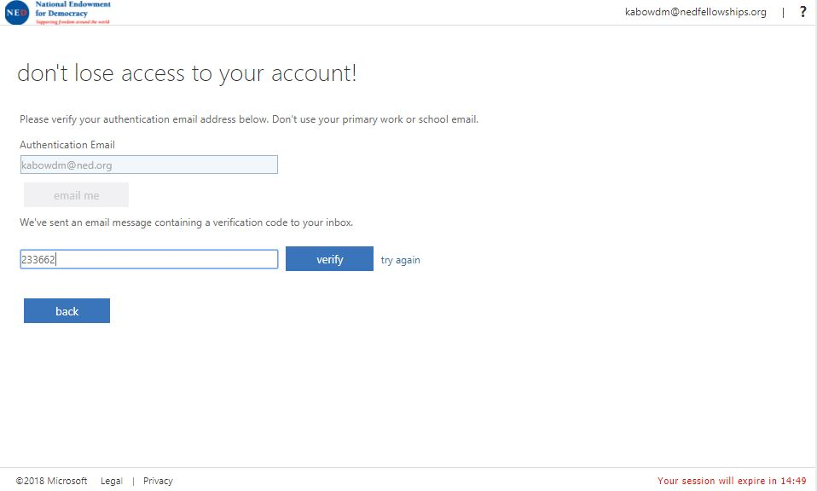

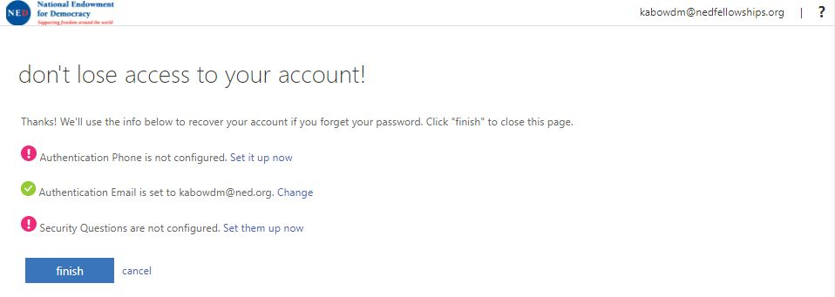
- Once either your phone or email is authenticated, or security questions are configured, you’ll be able to finish the account recovery portion, by clicking the ‘Finish’ button.

To complete authentication for phone, repeat Step 4, parts c, d and e. Remember that you may be charged for the cost of SMS message.
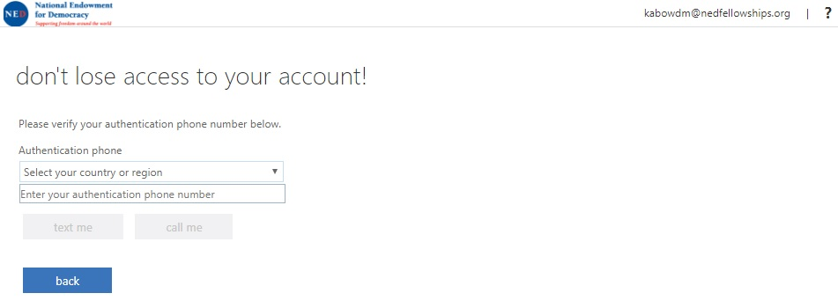

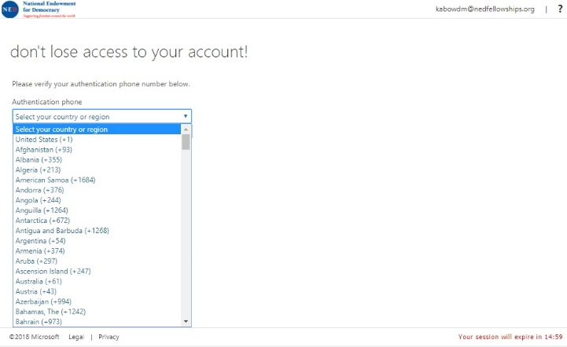

To complete authentication using the security questions, click on the drop down boxes, and pick your 3 questions and answer accordingly.
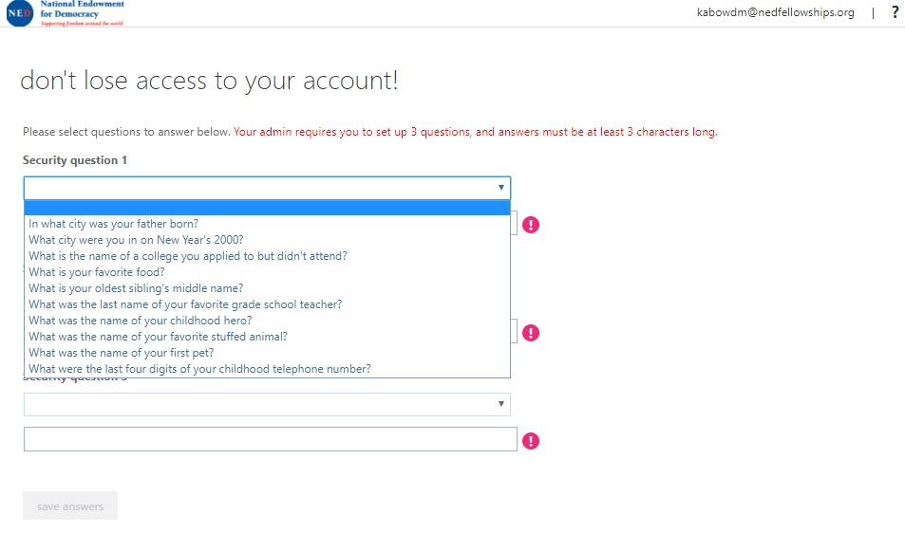

Finally, if you’re signed out because of time restraints, close the browser and restart it before you attempt to sign in again.
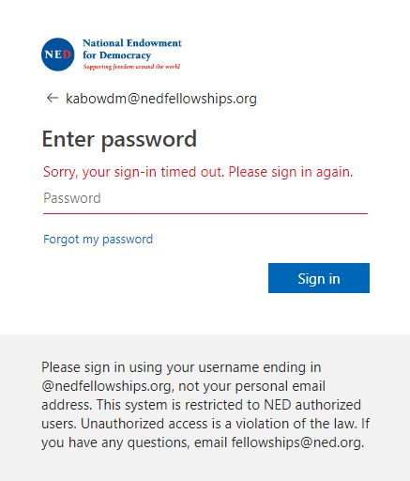

Step 5.
- When you’re ready, sign in with your username@nedfellowships.org and password.
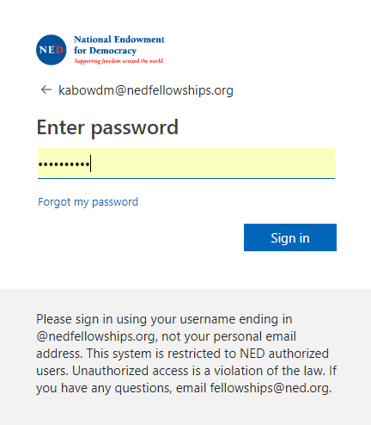
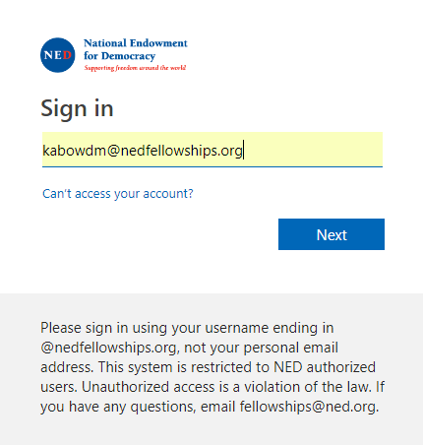

- Begin your application by clicking start.
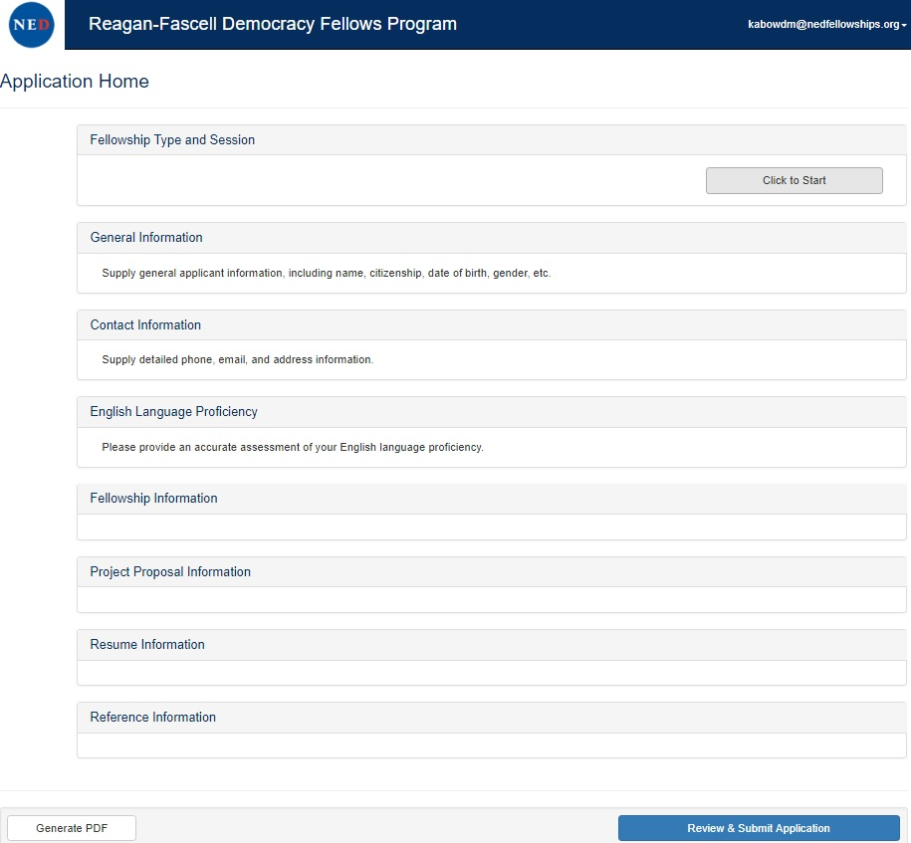

If you have any further questions, email fellowships@ned.org.
Good luck on your application!

